2025-26

Abstract: This project aims to design an intelligent traffic signal management system that adapts dynamically to real-time traffic conditions using Deep Reinforcement Learning (DRL) and computer vision. The proposed framework integrates a YOLOv8-based vehicle detection model with a Deep Q-Network (DQN) agent to optimize signal timings based on actual lane density, queue length, and waiting time. The system analyzes live video feeds from existing CCTV cameras to estimate traffic flow and allocate green times efficiently. Simulation results show that the proposed YOLOv8-DQN model reduces average vehicle delay by 50%, queue length by 57%, and improves overall throughput to 1440 vehicles per hour, achieving a fairness index of 0.90. The software-only approach eliminates the need for additional sensors, offering a scalable, cost-effective, and intelligent solution for smart city traffic control applications.


YESHWANTRAO CHAVAN COLLEGE OF ENGINEERING, NAGPUR
(An autonomous Institution Affiliated to Rashtrasant Tukadoji Maharaj Nagpur University)
DEPARTMENT OF COMPUTER TECHNOLOGY

ADAPTIVE TRAFFIC SIGNAL MANAGEMENT SYSTEM USING DEEP REINFORCEMENT LEARNING
NAME OF THE STUDENT: Girish Nandanwar, Bhushan More, Partho Ghoshal, Ashu Jenekar, Srujan Deshmukh
Group: CT-9 9999999
NAME OF THE GUIDE: Prof. Praful V. Barekar

Conclusion and Future scope:
In this project, real-time traffic optimization is achieved using YOLOv8 and Deep Reinforcement Learning (DQN). The system analyzes live CCTV feeds to detect vehicles and adjust signal timings based on lane density and queue length. The proposed model shows improved traffic flow with reduced average delay and queue length compared to traditional systems. The software-based design is low-cost, scalable, and ideal for smart city deployment.
Future Scope:
- Integration of pedestrian and emergency vehicle priority.
- Extension to multiple intersections for coordinated control.
- Improved accuracy under low-light or adverse weather conditions.
 | PO1 | PO2 | PO3 | PO4 | PO5 | PO6 | PO7 | PO8 | PO9 | PO10 | PO11 | PO12 | PSO1 | PSO2
CO1 | 3 | 3 | 3 | 3 | 3 | 3 | 3 | 3 |  | 3 | 3 | 3 |  | 3
CO2 | 3 |  | 3 | 3 | 3 | 3 | 3 | 3 |  | 3 | 3 | 3 | 3 | 3
CO3 |  |  |  |  |  |  |  | 3 | 3 | 3 | 3

Signature of Guide

Introduction:

Urban traffic congestion leads to longer travel times, fuel wastage, and higher pollution levels. Traditional signal systems like fixed-time and actuated controllers fail to adapt to dynamic traffic conditions. To address this, the proposed Adaptive Traffic Signal Management System integrates YOLOv8 for real-time vehicle detection with a Deep Q-Network (DQN) for intelligent signal control. By analyzing live CCTV feeds, the system dynamically adjusts green light durations based on lane density and queue length, reducing congestion and ensuring fair traffic flow. This software-based approach offers a cost-effective and scalable solution for smart city traffic management.

Methodology:
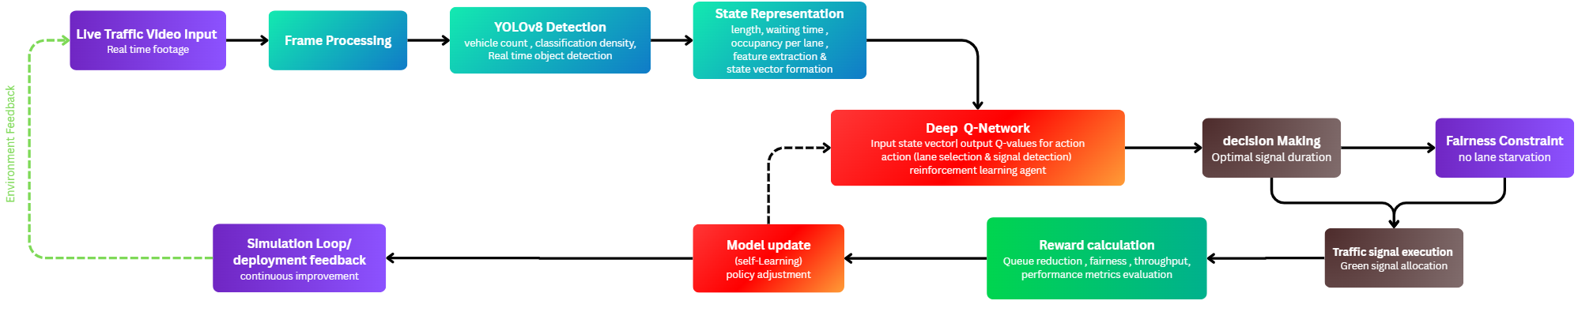

Results:
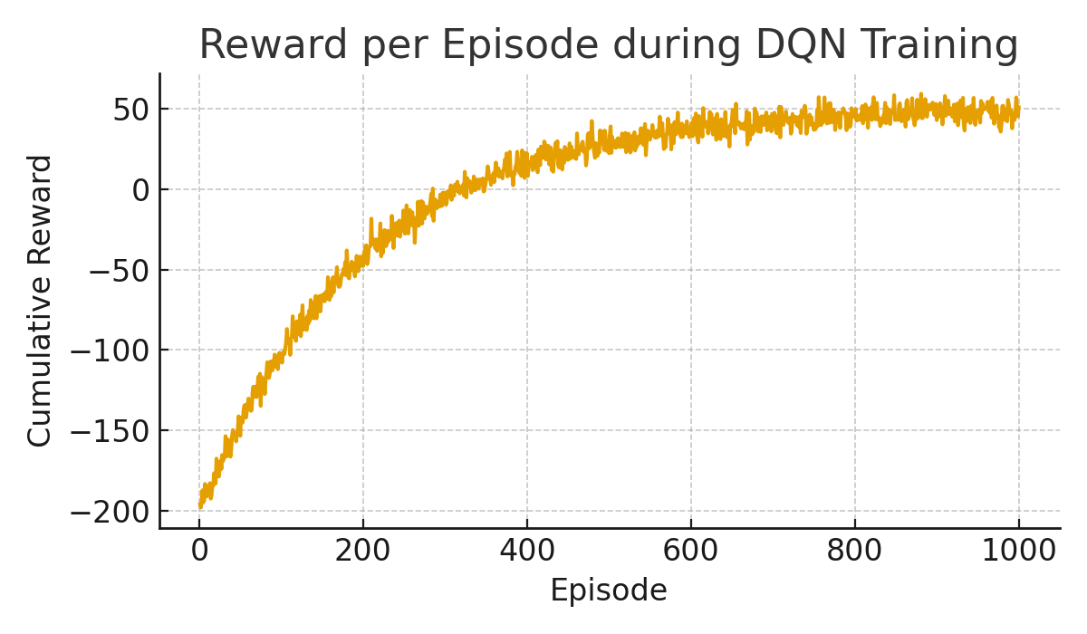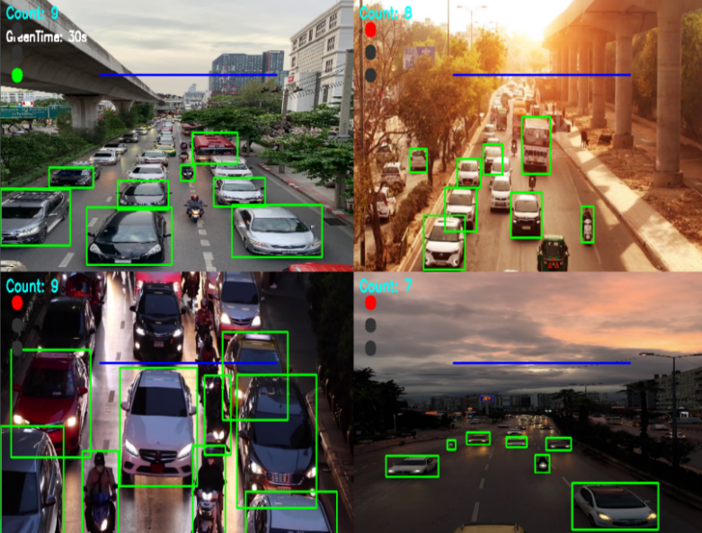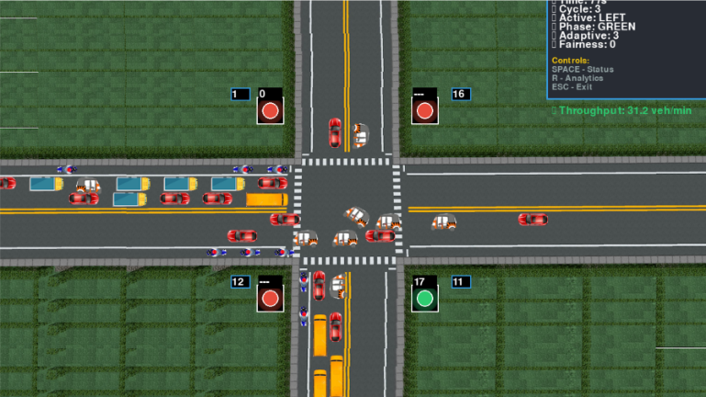
The proposed system was evaluated through simulation experiments using real-world traffic video data to assess its adaptability, efficiency, and accuracy. The YOLOv8-based vehicle detection module achieved a mean Average Precision (mAP@0.5) of 95.4% and an F1-score of 90.9%, ensuring precise identification of two-wheelers, light vehicles, and heavy vehicles under diverse lighting and congestion conditions. The extracted traffic features queue length, vehicle density, and waiting time served as input states for the DQN agent, which dynamically optimized signal timings. Experimental analysis demonstrated that the proposed YOLOv8-DQN framework reduced average vehicle delay by 50% and decreased queue lengths by 57%, while increasing throughput to 1440 vehicles per hour. Moreover, the system achieved a fairness index of 0.90, ensuring equitable green-time allocation across all lanes. The cumulative reward curve indicated stable convergence, validating effective learning and decision-making by the agent. Overall, the integrated computer vision and reinforcement learning framework significantly outperformed fixed-time, actuated, and model-predictive controllers, delivering real-time, adaptive, and cost-effective traffic management suitable for smart city deployment.

